**QUES-: PIG COMMANDS**

1. LOAD

Load data into Apache Pig from the file system (HDFS/ Local) using **LOAD** operator of **Pig Latin**

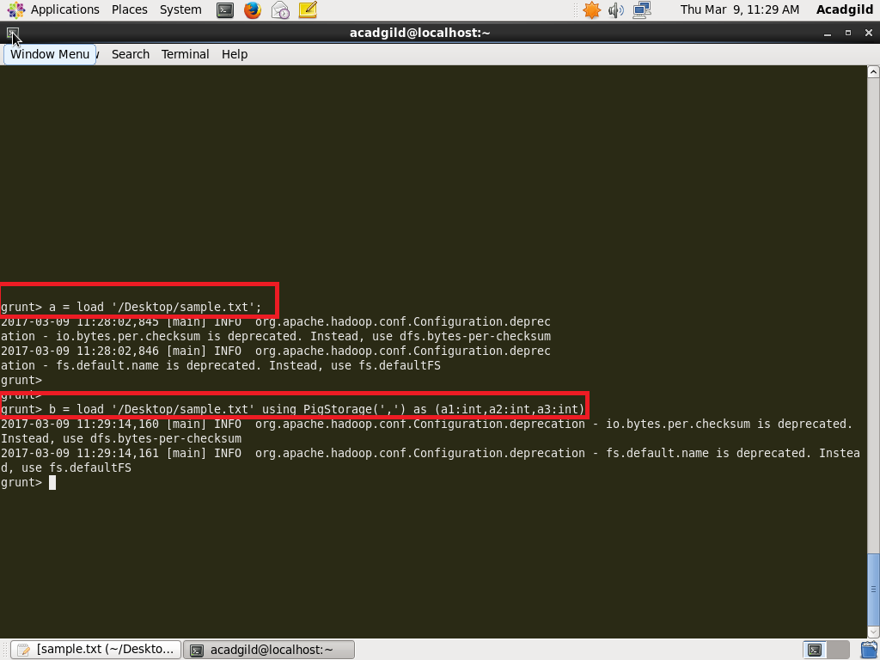

2. STORE

You can store the loaded data in the file system using the **store** operator.

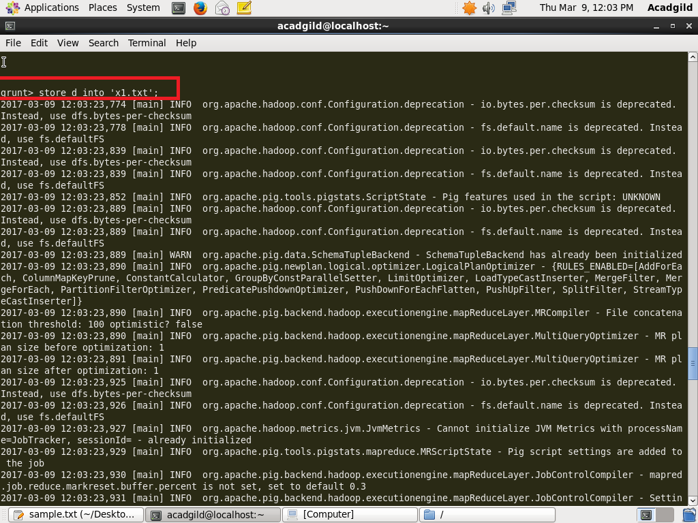

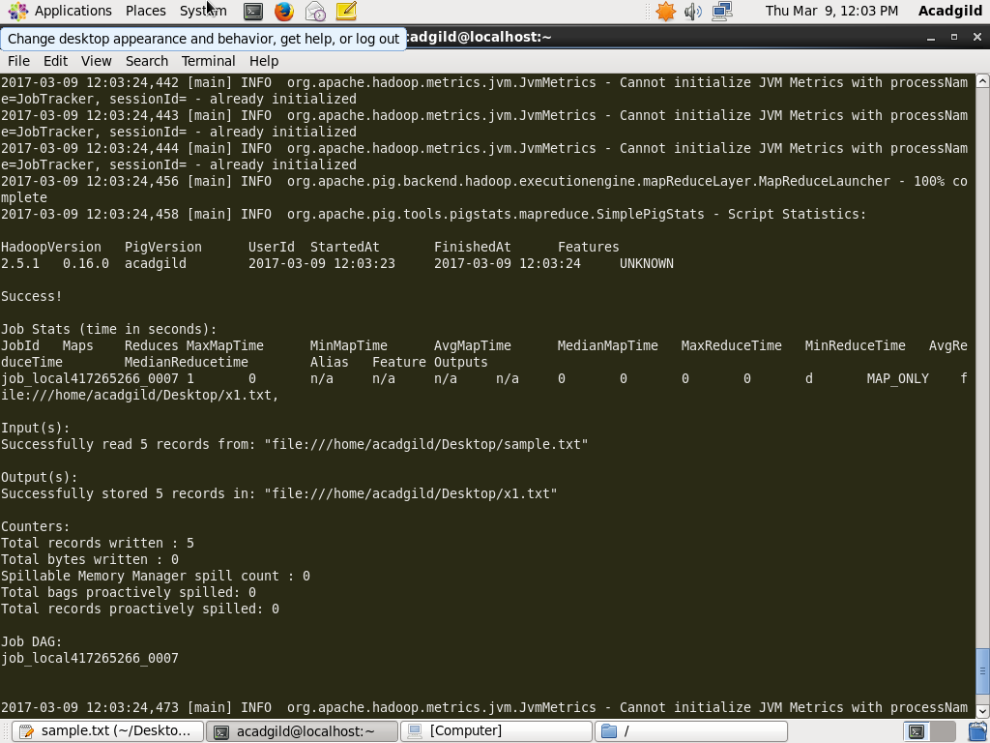

3. DUMP

The **Dump** operator is used to run the Pig Latin statements and display the results on the screen. It is generally used for debugging Purpose.

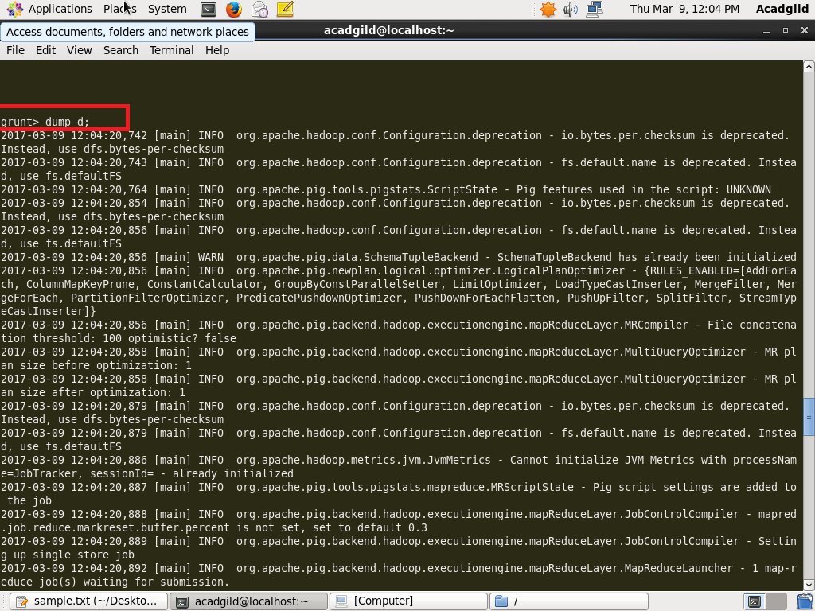

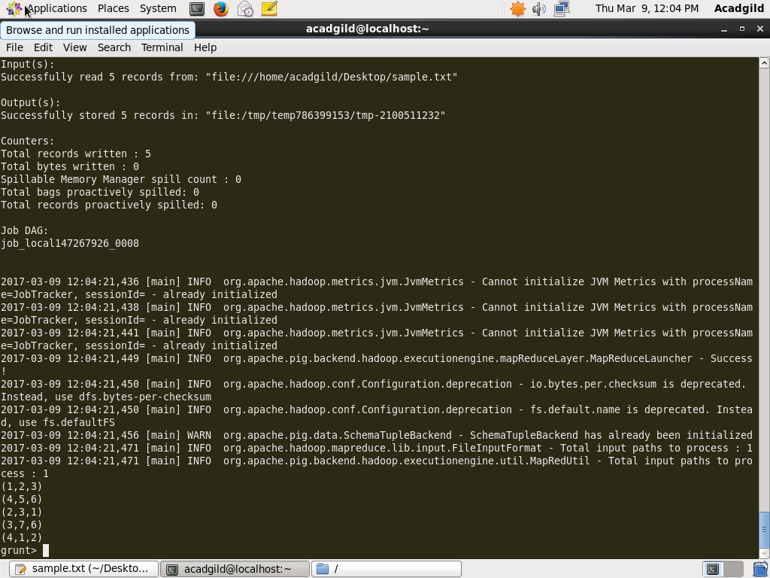

4. FOREACH

The **FOREACH** operator is used to generate specified data transformations based on the column data.

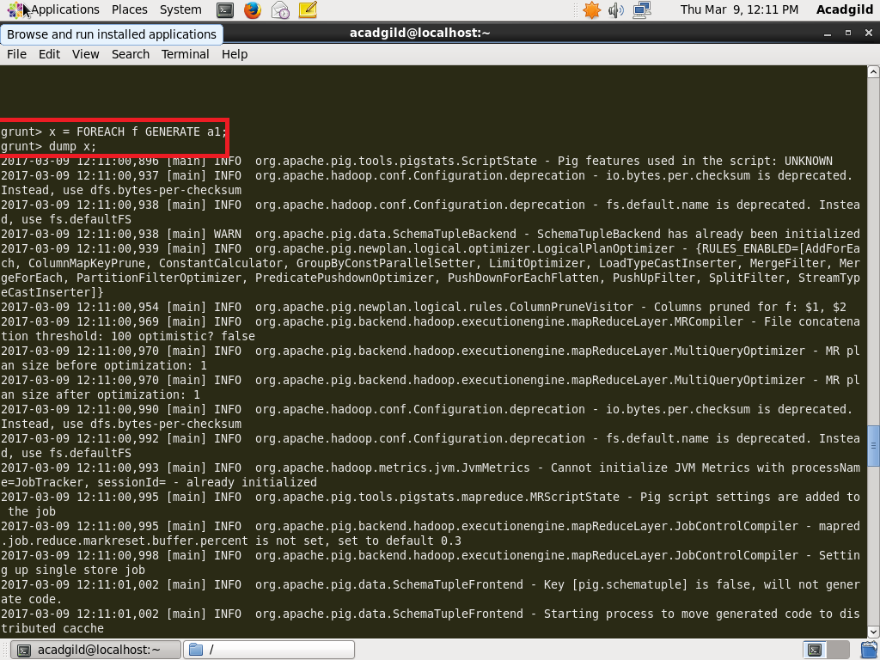



5. FILTER

The **FILTER** operator is used to select the required tuples from a relation based on a condition.

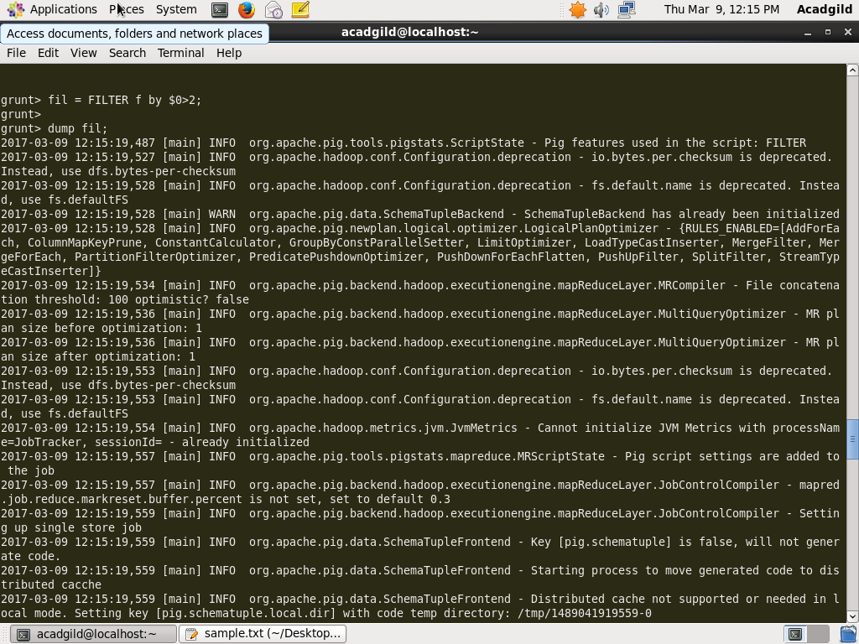

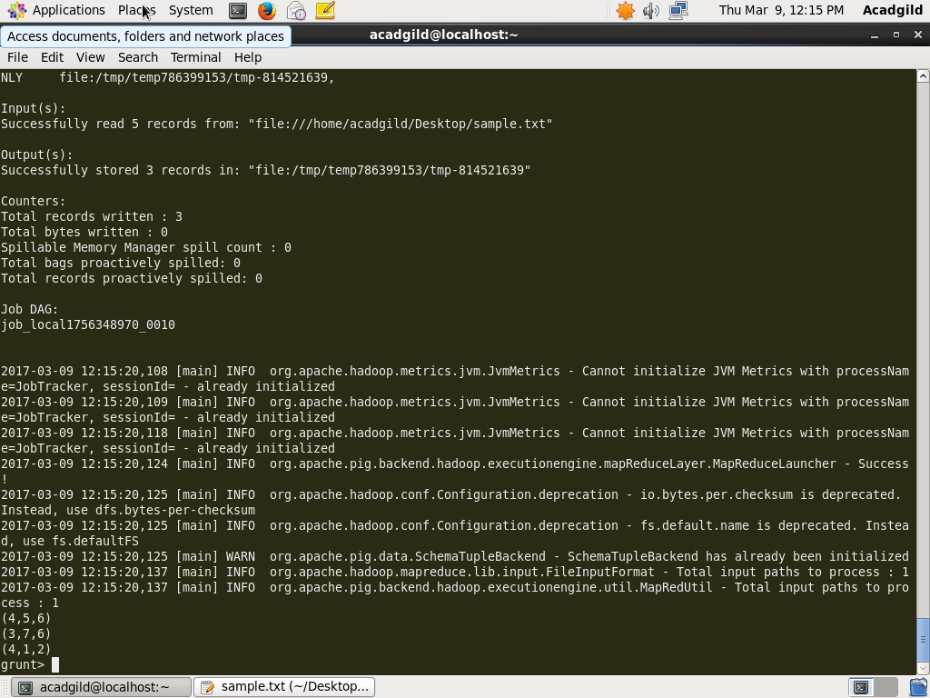

6. GROUP BY

The **GROUP** operator is used to group the data in one or more relations. It collects the data having the same key.

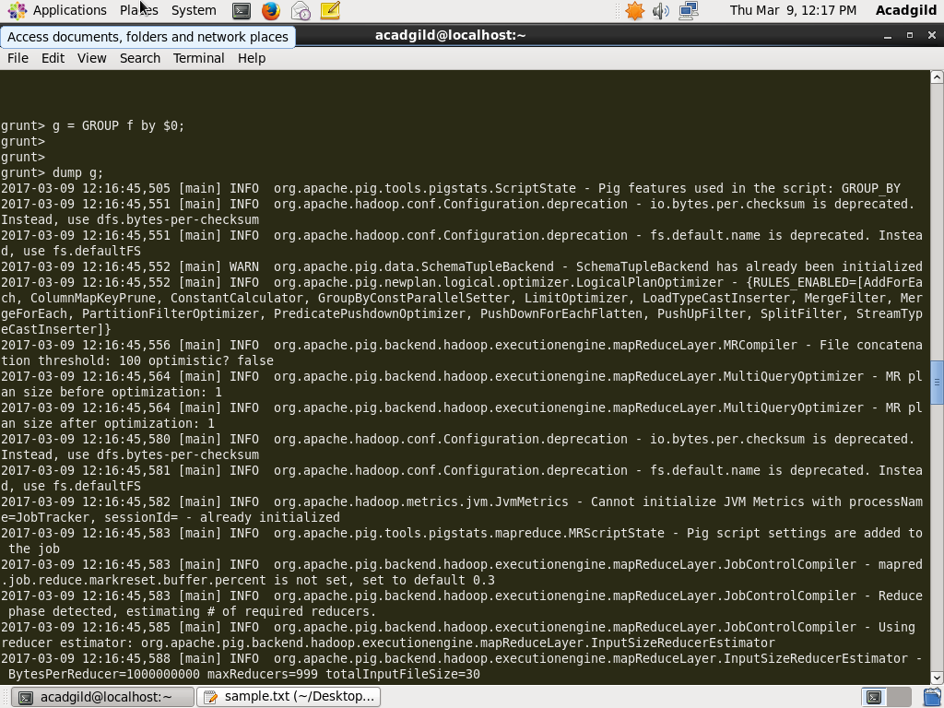

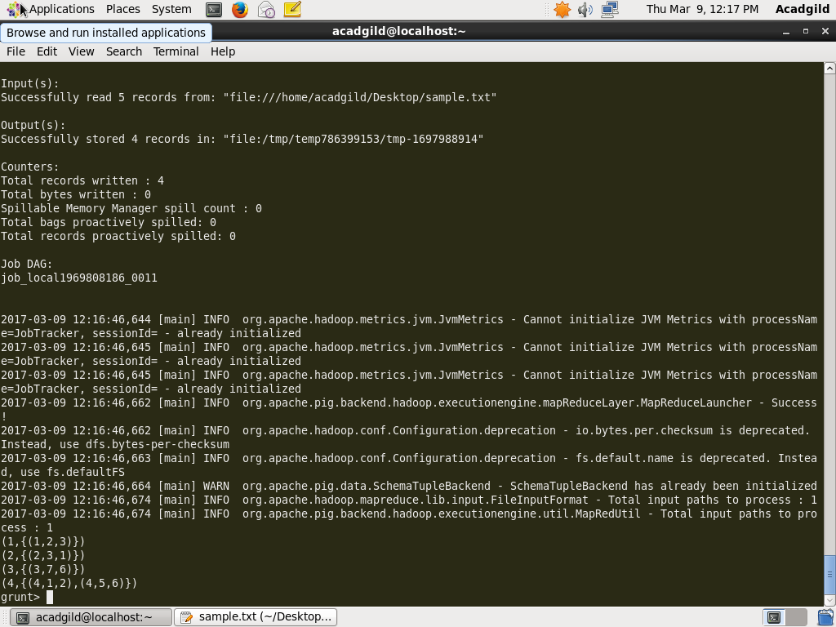

7. ORDER BY

The **ORDER BY** operator is used to display the contents of a relation in a sorted order based on one or more fields.

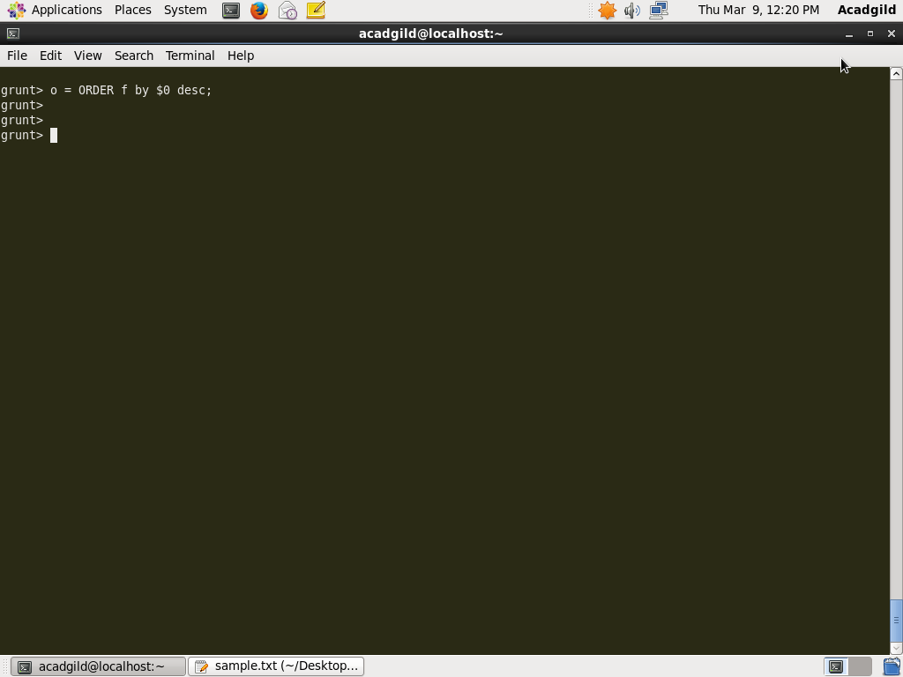

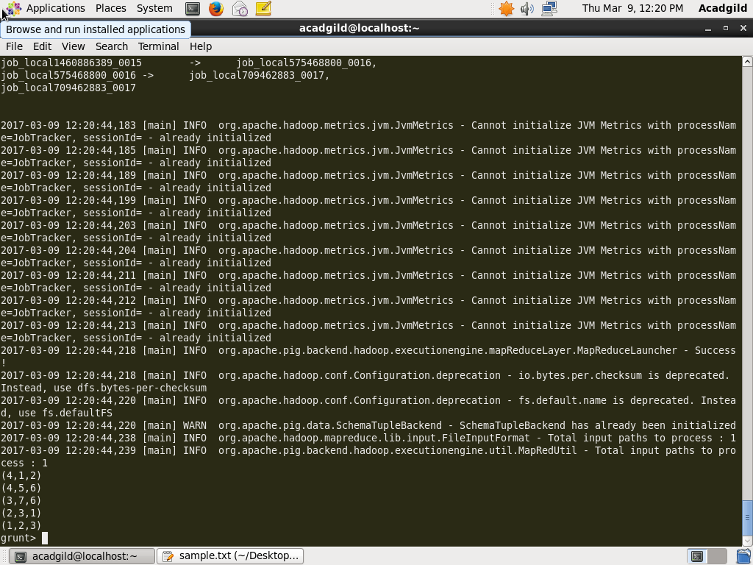

8. DESCRIBE

The **describe** operator is used to view the schema of a relation.

